**Heading:** Sprint 1 plan, MemLoc, Remind by Location, sprint completion date: 01.25, rev 1, 01/12/2022

Goal: Allowing users to provide location data to our app, and providing a basic UI interaction experience (early design phase)

**Task listing**

User story 1 : I want to be able to provide my location data for use within the app, so that I can eventually use that data for reminding me on the go. (9 points)

1. Setup new InfluxDB database instance (1h)
2. Integrate database with app (2h)
3. Start sending test data to app (4h)
4. Add all fields we need to database entries (2h)
5. Provide API for frontend to use (4h)

User story 2: As a user I want to be able to interact with the app in a basic way, so that I can add todo list items and have basic todo list functionality. (11 points)

1. Set up webpage that can be edited (1h)
2. Add some basic forms that could be filled out and add or remove tasks (1h)
3. Make it so there are different instances of the webster per the user (2h)
4. Add a homepage that allows for access to the different users(1h)

**Team roles:**

Alexandra: Frontend

Mythili: Backend

Abirami: Frontend

Surya Rani: Scrum Master, Backend

Case Delst: Product Owner, Backend, Frontend

Initial task assignment: A listing of each team member, with their first user story and task

assignment. This should look like:

Alexandra: User Story 2, Task 1,2

Mythili: User Story 1, Task 5

Abirami: User Story 2, Task 3, 4

Surya Rani: User Story 1, Task 2, 4

Case Delst: User Story 1, Task 3

Initial burnup chart: A graph giving the initial burnup chart for this sprint and is labeled as such

with sprint number and project name and is located in the lab.

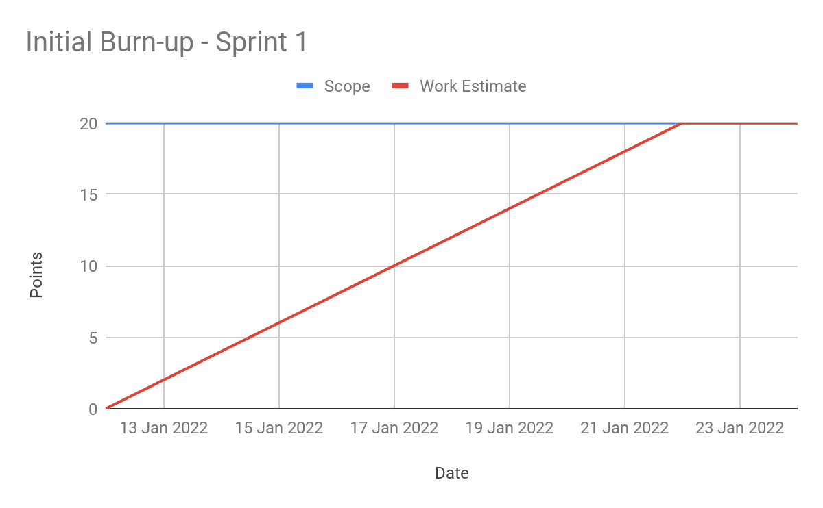

Initial scrum board:

<https://trello.com/b/GhjrTO9T/memloc-s1>

Scrum times:

Monday/Wednesday/Friday @ 3pm

Meeting with TA Wednesday @ 3:45